New Mobile Testing Tool for Economic Error Analysis
MCD Elektronik has developed a handheld testing tool for the after-sales market

Birkenfeld, Germany, October 13, 2015: The measurement technology specialist, MCD Elektronik, has presented its first mobile, battery-powered handheld tool. The company specializes in testing technology for electronic production. With this pleasingly designed testing tool, they are entering the after-sales field and providing tools to new target groups. “We originally developed this handheld testing tool for an automotive manufacturer, who is a renowned system partner and original equipment manufacturer, for testing exhaust flap actuators. The generally positive feedback from the customer induced us to make this tool available to other users”, explained Development Engineer, Gabor Tinneberg.

Based on a special 32-bit micro-control circuit, both analog and PWM-controlled components can be tested directly on the vehicle. The flexibly programmable MCD firmware has been prepared for functional testing of a variety of actuators and valves. The tool recognizes the connected device automatically and selects the corresponding test program. Using a dedicated Hall-Sensor input, components with non-integrated position indicators can also send the current position to the tool. An easy-to-read 4.3” LCD touch panel with a Pass/Fail indicator and graphical user interface will guide the user and indicate the measured data. The acoustic test signals from the speaker, which is integrated into the testing tool, extend communication with the user.

The handheld testing tool can be connected to a host computer using an
RS-232 interface and communicates with the MCD measurement software TestManager CE supplied with the tool. It can then exchange data and be controlled remotely. The mobile testing tool has been equipped with a practical standby switch and a start button.

A variety of testing cables can be delivered with the mobile testing tool for the diagnosis of control devices in the vehicle as well as in the medical technology sector. The tool will detect the “intelligent” cables and automatically adjust to the corresponding device under test. An additional, continuous checking feature monitors the power supply for sufficient capacity and will display any deviations.

The handheld testing tool has been equipped with a rechargeable battery with a capacity of 3,000 mA. This makes mobile usage and stable testing processes possible even with the connection of devices under test with high power requirements (up to 11A). If this is not sufficient, the tool can be connected to a power supply or an onboard power system using an external power connection (9 to 17V, typically 12V).

Pictures:
Picture 1: The handheld testing tool’s’ 4.3” LCD touch panel depicts the command selection from the programmed position tests in a clear manner and makes it easily accessible.

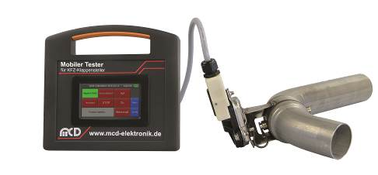
Picture 2: The mobile testing tool has already proven itself as a reliable, handy tool for testing exhaust flap actuators.

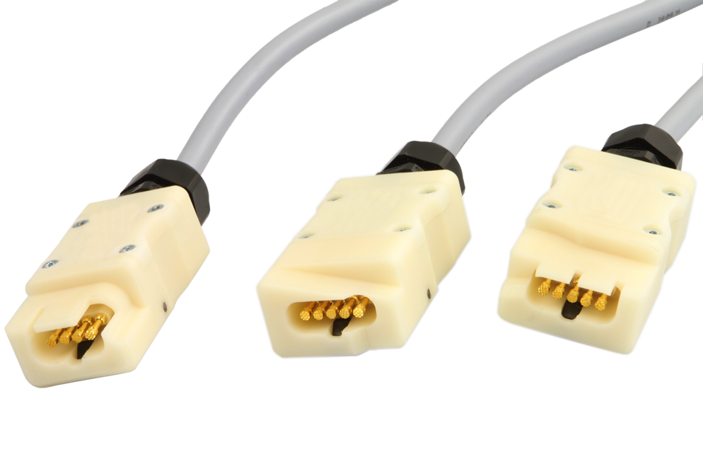
Picture 3: The right cable for each flap actuator; MCD will also deliver the appropriate testing cable for the mobile testing tool.

(© MCD Elektronik, Birkenfeld, Germany – Material free of charge as part of the publication of this press release)
About MCD Elektronik GmbH
MCD Elektronik GmbH manufactures measurement and test systems for electronic production for their customers; OEMs in the automotive industry, as well as representatives in the machine and system construction industries, the medical technology sector, defense and security technology, quality assurance and sensor and airplane construction.

MCD Elektronik GmbH was founded in 1983 by four people. They currently employ 80 people. The company is active in Germany, Hungary and China and delivers to 38 countries around the world. In order to keep in step with global competition and produce economically feasible products, MCD Elektronik relies on consistent quality assurance at a tolerance level of zero.

